all inclusive CONCEPT During Covid-19
We offer you an ultimate wine & dine experience in several outlets as below:
Meals   | Restaurants
 | 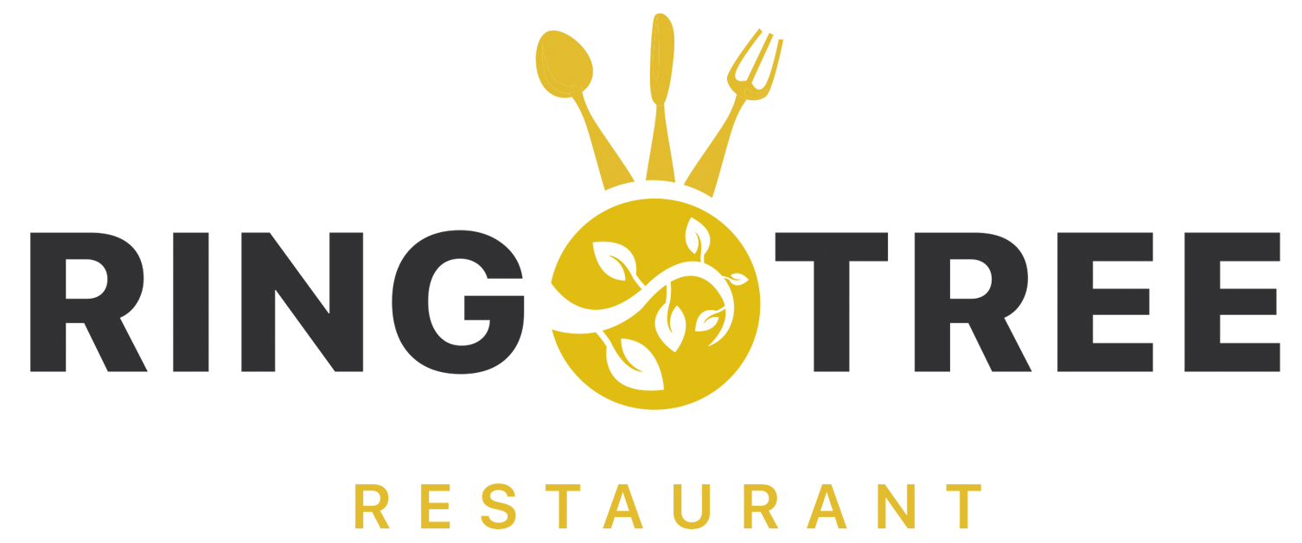 | 
 | International cuisine(Set Menu) | Italian cuisine(Set Menu)
 | Mealtime:  Breakfast 07.00-10.00;  Lunch 12.00-14.30;  Dinner 18.00-21.00.  Recently renovated and modernly designed in a hip chic style making it one of the most beautiful restaurants in Hurghada.  Characteristics: Do not miss hot fresh croissants straight out of the oven during breakfast time, hot fresh bakery served during lunch and dinner. | Mealtime:  Breakfast 07.00-10.00;  Lunch 12.30-14.00;  Dinner 18.00-20.30;  Recently renovated classical Italian restaurant with 2-week menu of Mediterranean buffet items, pasta station and pizza oven.  Characteristics: Pizza, passage to the Zomorodah restaurant (guest can pass between two restaurants freely to select items).
Drinks  snacks   | Bars
 | 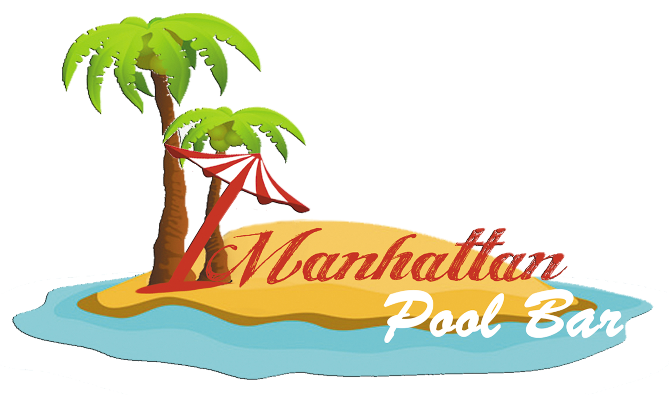 |  | 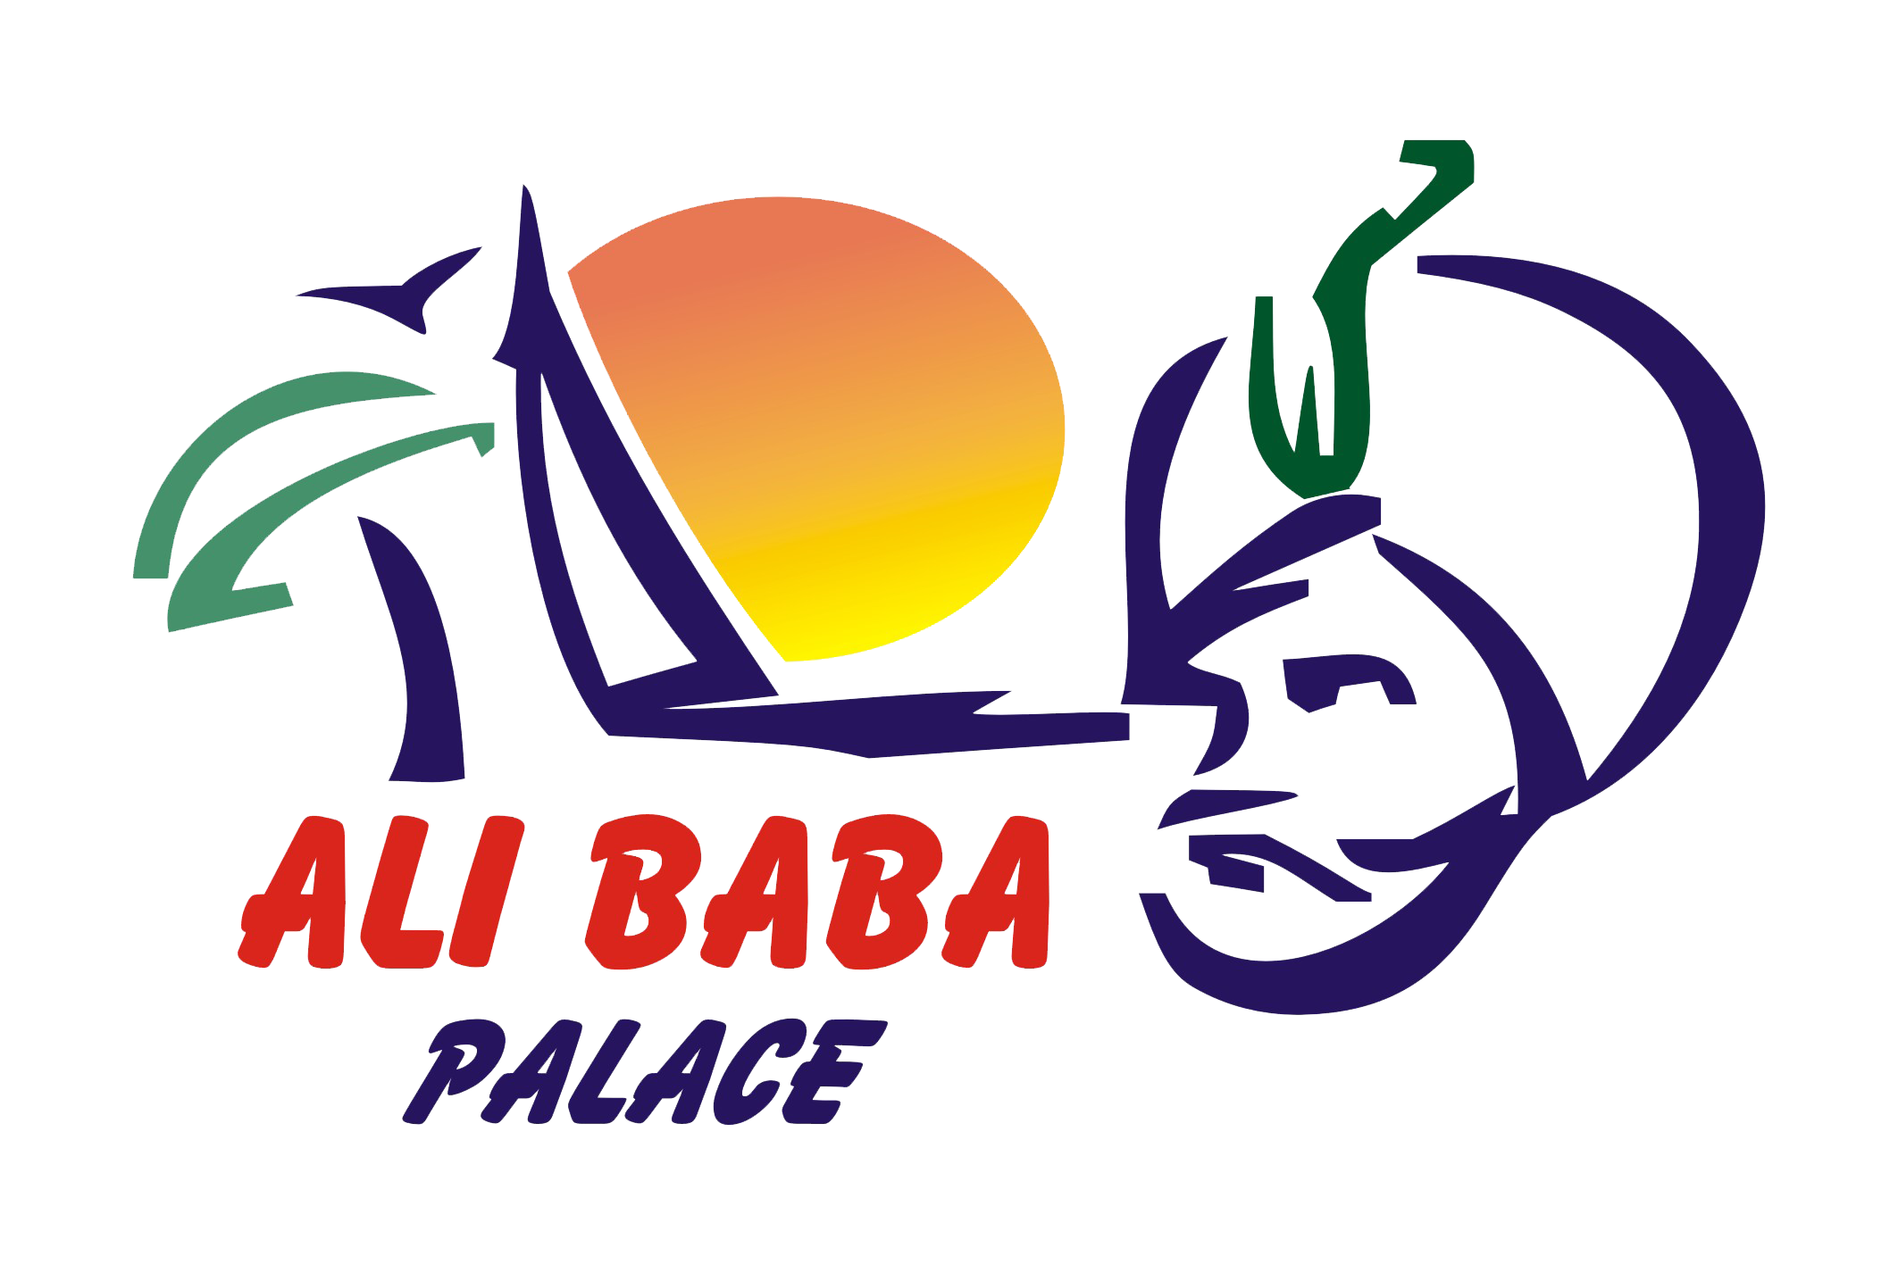 | 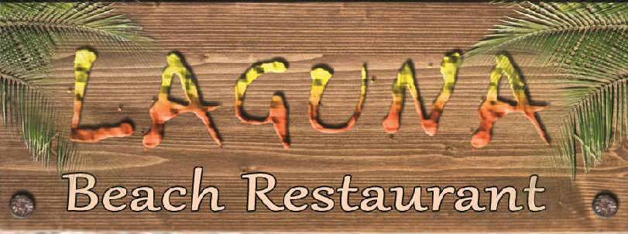
 | Pool Bar |  | Lobby Bar | Beach Bar & Restaurant
 | Open snack bar, operating hours: morning 08.00-11.00, lunch snacks 12.30-16.00, dinner 18.30-20.30 (summer). During lunchtime serving sandwiches, shawerma and kofta, french fries, salad bar. For dinnertime – BBQ and buffet with 2-week menu items*.  Characteristics: freshly made donuts 16.00-17.00, |  | Lobby bar, operating hours : 09:00 – 00:30.  Soft Drinks, Draft Beer, Wine, 6 kind of local alcohol between Liqueur and Spirits.  Café (station), cappuccino, tea. | Laguna Restaurant – open restaurant on the beach with 2-week menu, serving pasta, corndogs for kids, famous pizza, fresh grilled burgers daily 12.30-16.00.  Characteristics: Beachfast – Sunday breakfasts on the beach 07.00-11.00 (summer), Bedouin Night with open buffet every Thursday at 18.00.*
 | A la carte*
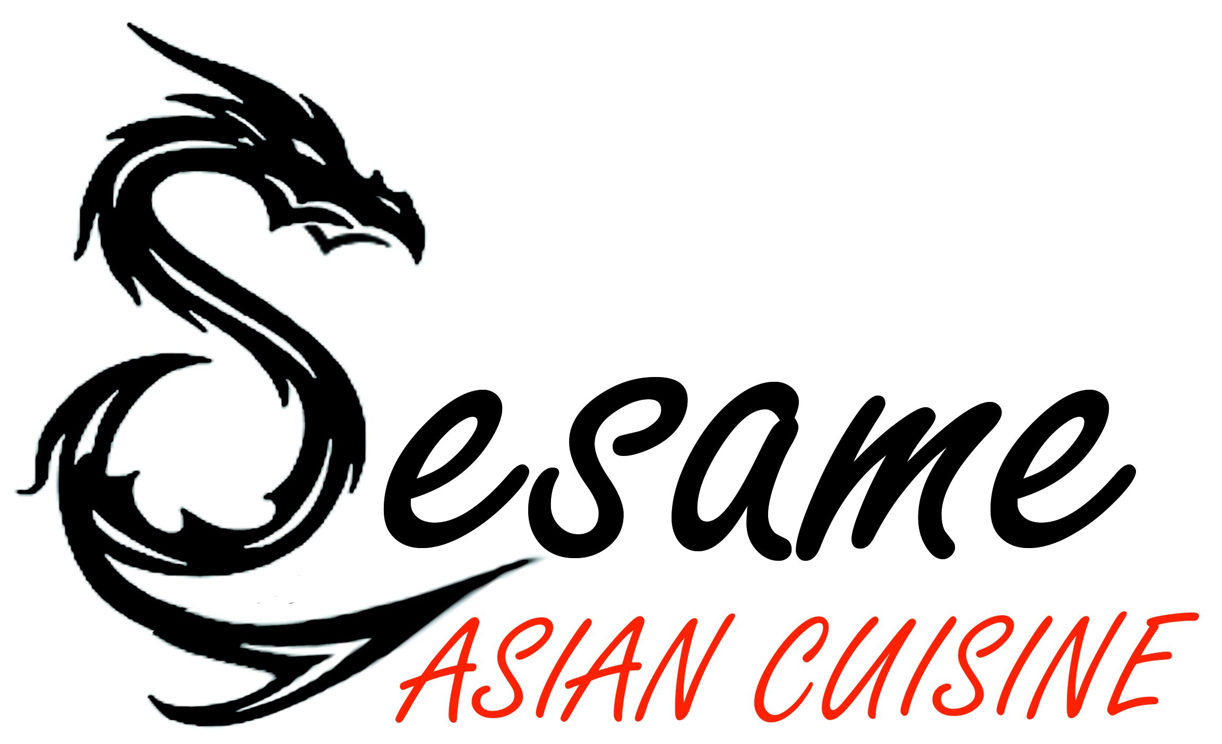 |  |  | Sesame – latest addition to our restaurants fleet of ala carte experience.  Asian Cuisine Restaurant, serving Sushi and Chinese, Indian menu daily 15.00-23.00. Dinner reservation for Ali Baba guests from 18.00 to 20.00.*  Characteristics: International Chefs team with very well-trained Sushi Chef creating authentic cuisine from raw fish to exotic spices straight out of India to Sesame kitchen.  Some items in the menu are free for Ali Baba guests and some items especially for the Thieves Package (black bracelet). Follow the logos in the menu.

*Advanced reservation is required
! Imported alcohol and some beverages are against payment.

